Game Design Document

Fill up the following document

1. Write the title of your project.

Temple run sai meera.k version

1. What is the goal of the game?

To collect coins

1. Write a brief story of your game.

The underplaying plot to game is that the person is controlled by the

Steals a gold idol from an temple which appears to be in a swamp

This causes the evil demon monkeys to attempt to catch the player in

Order to get the iodl back.

1. Which are the playing characters of this game?

* Playing characters are the ones who respond to the user based on the input from the user.
* Cars, monkeys, dinos, wizards, etc., are the playing characters in the game.

|  |  |  |
| --- | --- | --- |
| Number | Character Name | What can this character do? |
| 1 | BOY | Run vertically |
| 2 |  |  |
| 3 |  |  |
| 4 |  |  |
| 5 |  |  |
| 6 |  |  |
| 7 |  |  |
| 8 |  |  |

1. Which are the Non-Playing Characters of this game?

* Non-Playing characters are the ones that don't have an action or behavior when the user interacts with the game.
* Hurdles, stones, bananas, coins, etc., are non-playing characters in the game.

|  |  |  |
| --- | --- | --- |
| Number | Character Name | What can this character do? |
| 1 | Demon monkey | Run |
| 2 | coins | Score points |
| 3 |  |  |
| 4 |  |  |
| 5 |  |  |
| 6 |  |  |
| 7 |  |  |
| 8 |  |  |

Draw your imagination of this game. What does this game look like?

* Draw the game either on your computer or on paper.
* Add images of the game scenes to show each of the playing and non-playing characters at least once.

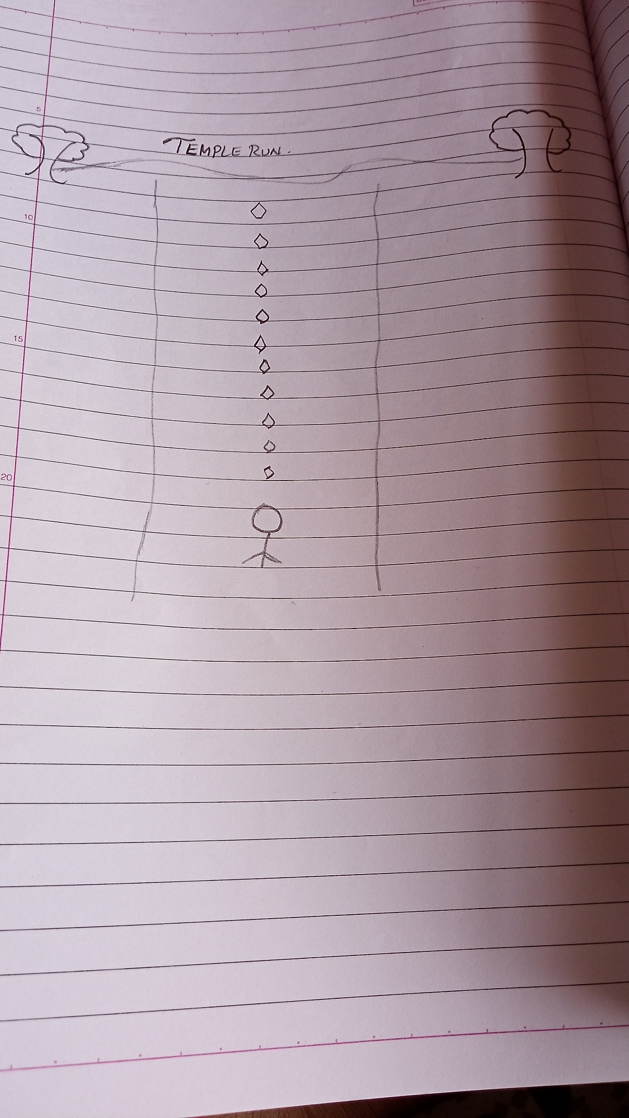

How do you plan to make your game engaging?

Increase the velocity and difficulties when the player .plays the game